HEREFORD SENIOR & VETS 1*

Point 4, Venns Lane, Hereford, HR1 1DT

Start Time: 8.30am

Saturday 4 & Sunday 5 March 2023

TTE Ranking event

(approved by TTE & Hereford CTTA)

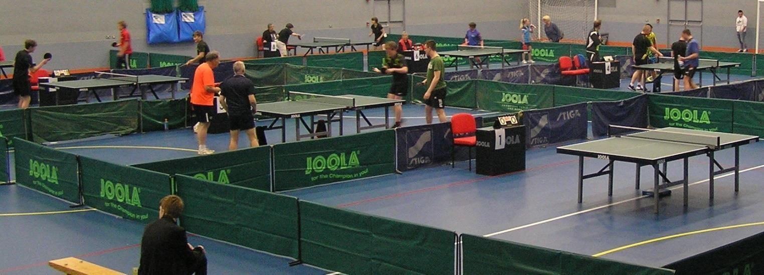

PLEASE PAY BY BACS
Account Details
HCTTA
Sort Code 53-50-41
Account Number 62463683
PLEASE USE YOUR NAME AS A REFERENCE ON BACS!!
And email entry form

Tournament Referee: Kyle Day
Tournament Organiser: Dylan Day
Entries to: Simon Morgan
136 Westfaling Street, Hereford, HR4 0JF
Tel: 07903 094128
E-Mail: simonmorgan1001@yahoo.co.uk
Organising Committee:
Kyle Day, Dylan Day, Simon Morgan, Richard Owens
Closing date for entries:
25 Feb 2023
Are you new to playing in tournaments?
If so, you may find Table Tennis England’s video for new players helpful, to find and view the video please click on the following link: -
Start competing - Table Tennis England

INFORMATION: This is an all-day competition open to male and female players. It will be run on a double group system followed by a knockout! The groups will be organised based on current ranking. Unranked players may be placed in a higher group if deemed appropriate by the Organising Committee.

Both days you should get 7 or 8 matches, it will be a tough weekend if you play both days.
TOURNAMENT REGULATIONS (to be retained)
- Every entrant must be affiliated as a Compete Member or be a member of another National Association in membership of the ITTF.
- Table Tennis England Tournament Regulations Part A (Regulated Competitions) and Part B (Tournament Regulations) apply to the tournament.
- ITTF Regulations for International Competitions apply to the tournament except where otherwise specified in TTE Regulations Part A or B, or in this form.
- Competitors will not be allowed to glue up within the confines of any of the buildings under any circumstances.
- Competition will be a mixture of groups and KO. All matches will be best of 5 games.
- The final order in a group shall be determined as per ITTF regulation 3.7.5 for group competitions.
- Playing clothing shall consist of a shirt and shorts, trousers, leggings or skirt, or a one-part sports outfit, socks and playing shoes; a sports hijab may also be worn. Other garments shall not be worn during play except with the permission of the referee. The main colour of a shirt, shorts, trousers or skirt, other than sleeves and collar of a shirt, shall be clearly different from that of the ball in use.
- No competitor or official shall engage in betting on players or matches.
- All competitors may be required to umpire at least one match in each event entered.
- Doping shall not take place either before or during play and doping control tests may take place.
- For Veteran events, entrants must be born before the 1st of January 1983.
- Completion and submission of this entry form signifies agreement by the entrant to the conditions of the competition including any variations of ITTF regulations.
- All Competitors must report to the Booking-In Control on arrival and should not leave the hall without first obtaining permission from the Referee. Players absent when called upon to play are liable to be scratched.
- Should there be insufficient entries in any event the Referee reserves the right to cancel that event/merge such event and/or place the entrant in a similar event.
- The referee’s decision shall be final on a point of law and on any question arising not provided for in these regulations, or in any dispute as to the interpretation thereof.
- All events will be based on the Table Tennis England ranking list effective on the closing date for entries. The organiser reserves the right to place any unranked players in the grade(s) he feels appropriate. All events will be seeded.

TOURNAMENT INFORMATION
- Entry forms - Further entry forms are available from and should be returned to Simon Morgan (Assistant Organiser), at simonmorgan1001@yahoo.co.uk or 136 Westfaling Street, Hereford, HR4 0JF; by 25 Feb 2023.
- The draw will take place on the 26 Feb 2023 at 136 Westfaling Street, Hereford, HR4 0JF at 1pm. If it becomes necessary to restrict entries, priority will be given in order of receipt.
- No entry will be accepted after the draw has been made.
- The event is an all-day event, all players should get at least 7 matches.
- Practice – There will be no separate practice facilities.
- Play will be on 10 Joola Tables with Joola nets and White Joola Flash 3* balls. Court size will be 11.5m x 6.9m enclosed by surrounds. Scoring machines will be used for all matches. The floor is a seamless polyurethane surface. General fluorescent lighting is 10m above the table. Assistant umpires will not be appointed.
- Car parking (at the owner’s risk) is available at the venue, there is an all-day charge of £5.
- Admission – there will be no admission charge.
- Changing rooms and showers can be used for showering or changing.
- There is some food and drinks available at venue café.
- Vouchers or trophies will be presented to all winners and runners-up.
- Players should retain this sheet of regulations and information.
- All entries and event details are subject to COVID-related restrictions, or protocols that Table Tennis England may deem necessary. Venues used for events may impose COVID restrictions that go beyond government guidance.
- All participants and attendees at Table Tennis England events are subject to Table Tennis England Codes of Conduct. Please see https://www.tabletennisengland.co.uk/about-us/safeguarding/safeguarding-codes-of-conduct-and-terms-of-reference/
- TTE, the Organisers and the Referee will not tolerate bad language or verbal abuse of volunteers, officials, staff or venue staff, nor a failure to follow the operational directions of stewards and event staff. We will treat all such instances extremely seriously and will take disciplinary action if necessary. For further details, please see the Table Tennis England Workforce Protection Policy https://www.tabletennisengland.co.uk/about-us/policies-and-procedures/
- Photo/livestreaming: Hereford CTTA may be taking photos and live streaming matches during this event which may include (but not limited to), using them in our printed and online platforms, social media, press releases and funding applications. If you do not give permission to take photographs and/or video of you (or individuals for whom you are legally responsible), please contact simonmorgan1001@yahoo.co.uk Please be aware that we follow the Table Tennis England’s Photo and live streaming Policy: https://www.tabletennisengland.co.uk/about-us/safeguarding/photography-guidelines/

Directions

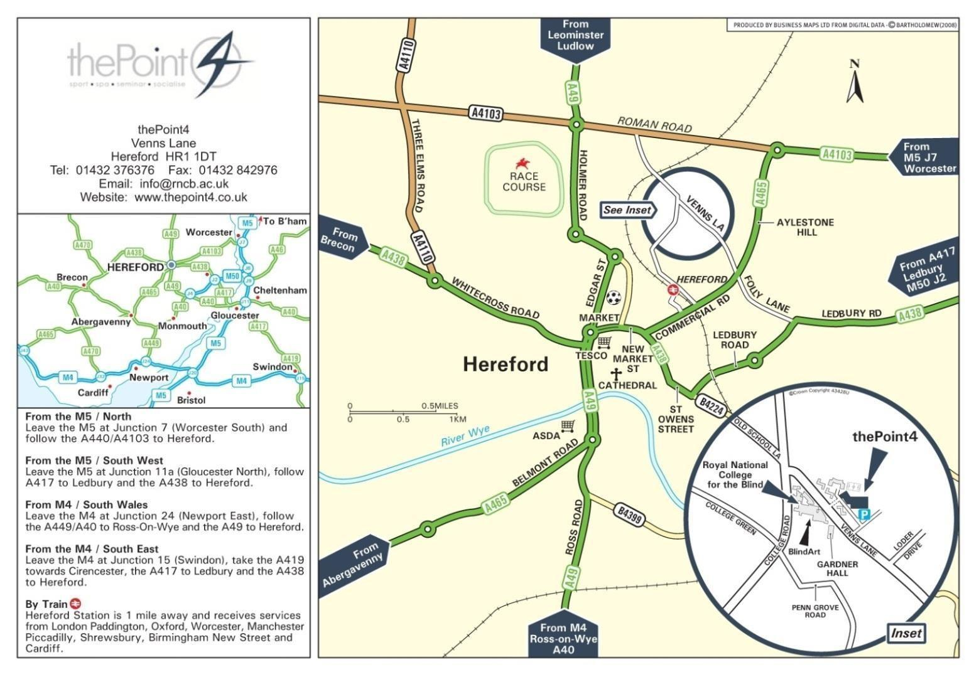

HEREFORD OPEN & VETS 1*
Please complete in BLOCK CAPITALS using a ball-point pen. A separate entry form must be completed by each player and sent to the Assistant Organiser: Simon Morgan, 136 Westfaling Street, Hereford, HR4 0JF, simonmorgan1001@yahoo.co.uk
To arrive not later than 25 Feb 2023

Name
Address
DOB
Mobile
Email

You must fill in Licence Number and County please!!

Table Tennis England Licence Number:
County of Affiliation:
If not affiliation to TTE, name of National Association
Please detail any relevant disability, accessibility, or health issues:

Saturday 4 March 2023 – Open | £25.00
Sunday 5 March 2023 – Vets | £25.00
All TTE levies covered by entry fee | Total: | £

NO ENTRY WILL BE ACCEPTED UNLESS THE FOLLOWING UNDERTAKING IS SIGNED:
I undertake to observe the regulations of the tournament, to abide by the decisions of the Referee, and to fulfil the schedule of play arranged for me unless prevented from doing so by circumstances beyond my control and accepted as such by the Referee.

Table Tennis England requires consent to the use of personal data in the administration of this competition, in accordance with the TTE Privacy Policy; the information will be shared where necessary with the organisers and event committee. For a player under 16 this consent must be given by a parent or guardian, who must also confirm agreement to the player’s participation in the competition. The TTE Privacy Policy is at https://www.tabletennisengland.co.uk/privacy-policy/

Print Player Name ………………………………………………………………………………

If player is 16 or over:
Data Protection: I am the player named above and I consent to the use by TTE of my personal data in the administration of this competition.

Signed: ................................................................. Date …………………………………………

If player is under 16:
Data Protection & Activity Consent: I have legal responsibility for the player named above and I consent to his/her participation in the competition, and to the use by TTE of his/her personal data in its administration.

Name: (Block Capitals) .............................................. Relationship to player: .............................. Signed: ....................................

Date ……………………………..

The UK Anti-Doping Rules apply to all persons entering an event or competition, for whichever is the longer of a) the length of their membership or licence period; or b) 12 months from the date of their participation, whether or not the entrant or licence holder is a citizen of, or resident in, the UK.

A player under 18 may not participate in a Table Tennis England event or competition unless a parent or guardian of that player has consented to testing of that player in the following form:

If player is under 18:
Anti-Doping Acknowledgment:
I have legal responsibility for the player named above and I confirm that I have read the TTE Anti-Doping
Regulations (Appendix P) and that I hereby acknowledge that the player is bound by these Regulations.

Name: (Block Capitals) .............................................. Relationship to player: ............................... Signed: ....................................

Date ……………………………...

